Project Documentation



Project Name: MEDICS: MEDICAL EXAMINATION AND DIAGNOSIS INFORMATION CARE SYSTEM
Project Link: https://github.com/codingwithnsh/MEDICS
Group Members: 1) Naman Shettigar
2) T.Sharan Pai
3) Sweekrath K
Class: 11
Section: B

Submitted On:

Submitted To: Tr. Shilpa A.G

INDEX

Serial Number | Title | Page Number
1. | Certificate | I
2. | Acknowledgement | II
4. | Algorithm | 1
5 | Source Code | 2
6. | Output Screen | 12
7. | Future Enhancements | 15
8. | Hardware and Software Requirements | 16
10. | Reference | 17
9. | Thank You | 18


CERTIFICATE

This is to certify that Naman Shettigar, has satisfactorily completed their minor project in the subject Computer Science on the topic MEDICS: MEDICAL EXAMINATION AND DIAGNOSIS INFORMATION CARE SYSTEM during the Academic Year 2024-25.

Examination Date :

Place :

_______________ ______________
Teacher in charge Principal

________________ _______________
Practical Examiner School Stamp

CERTIFICATE

This is to certify that T. Sharan Pai, has satisfactorily completed their minor project in the subject Computer Science on the topic MEDICS: MEDICAL EXAMINATION AND DIAGNOSIS INFORMATION CARE SYSTEM during the Academic Year 2024-25.

Examination Date :
Place :

_______________ ______________
Teacher in charge Principal

________________ _______________
Practical Examiner School Stamp

CERTIFICATE

This is to certify that Sweekrath K, has satisfactorily completed their minor project in the subject Computer Science on the topic MEDICS: MEDICAL EXAMINATION AND DIAGNOSIS INFORMATION CARE SYSTEM during the Academic Year 2024-25.

Examination Date :
Place :

_______________ ______________
Teacher in charge Principal

________________ _______________
Practical Examiner School Stamp

ACKNOWLEDGMENT

I express my sincere gratitude to Mrs. Swathi Kulkarni, our respected Principal, for her encouragement and support throughout this project. Her guidance and motivation have been instrumental in the successful completion of my work.
I extend heartfelt thanks to my computer teacher, Mrs. Shilpa A.G, for her invaluable assistance, mentorship, and constructive feedback, which greatly contributed to my learning experience and the quality of my project.
I would also like to express my deepest gratitude to my parents for their constant support, encouragement, and understanding. Their unwavering belief in my abilities and their help throughout this project have been a tremendous source of strength.
Finally, I am grateful to everyone who contributed, directly or indirectly, to the success of this project.

ALGORITHM

Step 1: Start
Step 2: Initialize the required libraries and dependencies: os, tkinter, pandas, and PIL
Step 3: Load the database.xlsx file containing user data into a Pandas DataFrame (users_df)
Step 4: Check if users_df contains all required columns; if yes, proceed to Step 5, else add missing columns and proceed to Step 5
Step 5: Create the Tkinter root window with a title and default size
Step 6: Define global variables for current_user and results_frame
Step 7: Display the login screen with fields for username and password, and a "Signup" button at the bottom
Step 8: Check user selection; if "Login," proceed to Step 9, else if Signup, go to Step 12.
Step 9: Verify the credentials against the users_df; if valid, set current_user and go to Step 15, else display an error message and return to Step 7
Step 10: If "Signup" is selected, display signup fields for name, username, password, city, and address
Step 11: Validate the inputs and check for duplicate usernames in users_df; if valid and username is unique, proceed to Step 12, else display an error message and return to Step 10
Step 12: Add the new user to users_df, save the updated data, and return to Step 7
Step 13: If the logged-in user is a patient, proceed to Step 14
Step 14: Display the patient dashboard with fields for symptom input
Step 15: Submit the symptoms and map them to a medical specialization; if a match is found, proceed to Step 16, else display an error message and return to Step 14
Step 16: Show a list of doctors in the patient’s city
Step 17: Allow the patient to select a doctor and an appointment slot
Step 18: Save the appointment details to users_df
Step 19: If the logged-in user is a doctor, display the doctor dashboard with a list of assigned patients
Step 20: Allow the doctor to view patient details.
Step 21: Save updates to the patient records in users_df
Step 22: Stop

SOURCE CODE
import os
import tkinter as tk
from tkinter import messagebox, ttk
from PIL import Image, ImageTk
import pandas as pd
import textwrap
# Get the directory of the script
script_dir = os.path.dirname(os.path.abspath(__file__))
# Load Excel database
users_df = pd.read_excel(os.path.join(script_dir, 'database.xlsx'), sheet_name='users')
filtered_specializations = set()
# Ensure proper column types
users_df['Symptoms'] = users_df['Symptoms'].astype(str)
if 'Appointment Slot' not in users_df.columns:
users_df['Appointment Slot'] = ''
if 'Preferred Doctor' not in users_df.columns:
users_df['Preferred Doctor'] = ''
# Main root window
root = tk.Tk()
root.title('MEDICS: MEDICAL EXAMINATION AND DIAGNOSIS INFORMATION CARE SYSTEM')
root.geometry('800x600')
# Global variable for the currently logged-in user
current_user = None
# Global variable for results_frame
= None
# Global variable for confirm button
confirm_btn = None
def show_view(view, matched_specialization=None):
for widget in root.winfo_children():
widget.destroy()
if view == 'login':
show_login()
elif view == 'signup':
show_signup()
elif view == 'patient':
show_patient_dashboard()
elif view == 'doctor':
show_doctor_dashboard()
elif view == 'select_doctor':
show_select_doctor(matched_specialization)
def show_login():
frame = ttk.Frame(root, padding="20")
frame.pack(fill='both', expand=True)
# Load and display image
img = Image.open(os.path.join(script_dir, 'login_image.png'))
img = img.resize((400, 399), Image.LANCZOS)
img = ImageTk.PhotoImage(img)
img_label = ttk.Label(frame, image=img)
img_label.image = img # Keep a reference to avoid garbage collection
img_label.pack(pady=10)
ttk.Label(frame, text='Username').pack(pady=5)
username_entry = ttk.Entry(frame)
username_entry.pack(pady=5)
ttk.Label(frame, text='Password').pack(pady=5)
password_entry = ttk.Entry(frame, show='*')
password_entry.pack(pady=5)
login_btn = ttk.Button(frame, text='Login', command=lambda: authenticate_user(username_entry, password_entry))
login_btn.pack(pady=10)
signup_btn = ttk.Button(frame, text='Sign Up', command=lambda: show_view('signup'))
signup_btn.pack(pady=10)
def show_signup():
frame = ttk.Frame(root, padding="20")
frame.pack(fill='both', expand=True)
ttk.Label(frame, text='Name').pack(pady=5)
name_entry = ttk.Entry(frame)
name_entry.pack(pady=5)
ttk.Label(frame, text='Username').pack(pady=5)
username_entry = ttk.Entry(frame)
username_entry.pack(pady=5)
ttk.Label(frame, text='Password').pack(pady=5)
password_entry = ttk.Entry(frame, show='*')
password_entry.pack(pady=5)
ttk.Label(frame, text='City').pack(pady=5)
city_entry = ttk.Entry(frame)
city_entry.pack(pady=5)
ttk.Label(frame, text='Address').pack(pady=5)
address_entry = ttk.Entry(frame)
address_entry.pack(pady=5)
ttk.Label(frame, text='Specialization (if Doctor)').pack(pady=5)
specialization_entry = ttk.Entry(frame)
specialization_entry.pack(pady=5)
signup_btn = ttk.Button(frame, text='Sign Up', command=lambda: register_user(name_entry, username_entry, password_entry, city_entry, address_entry, specialization_entry))
signup_btn.pack(pady=10)
login_btn = ttk.Button(frame, text='Back to Login', command=lambda: show_view('login'))
login_btn.pack(pady=10)
def register_user(name_entry, username_entry, password_entry, city_entry, address_entry, specialization_entry):
global users_df
name = name_entry.get()
username = username_entry.get()
password = password_entry.get()
city = city_entry.get()
address = address_entry.get()
user_type = 'Doctor' if specialization_entry.get() else 'Patient'
specialization = specialization_entry.get() if user_type == 'Doctor' else ''
if not name or not username or not password or not city or not address or (user_type == 'Doctor' and not specialization):
messagebox.showerror('Error', 'All fields are required.')
return
if username in users_df['Username'].values:
messagebox.showerror('Error', 'Username already exists.')
return
new_user = pd.DataFrame([[name, username, password, address, city, '', '', '', user_type, specialization, '', '']],
columns=['Name', 'Username', 'Password', 'Address', 'City', 'Diagnosis', 'Appointment Slot', 'Preferred Doctor', 'User Type', 'Specialization', 'Assigned Patients', 'Doctor ID'])
users_df = pd.concat([users_df, new_user], ignore_index=True)
save_data()
messagebox.showinfo('Success', 'User registered successfully.')
show_view('login')
def authenticate_user(username_entry, password_entry):
global current_user
current_user = None # Reset current_user on each login attempt
username = username_entry.get()
password = password_entry.get()
user = users_df[(users_df['Username'] == username) & (users_df['Password'] == password)]
if not user.empty:
current_user = username
user_type = user['User Type'].values[0]
if user_type == 'Patient':
show_view('patient')
elif user_type == 'Doctor':
show_view('doctor')
else:
messagebox.showerror('Error', 'Invalid username or password.')
def show_patient_dashboard():
global results_frame
frame = ttk.Frame(root, padding="20")
frame.pack(fill='both', expand=True)
# Load and display image
img = Image.open(os.path.join(script_dir, 'patient_dashboard_image.png'))
img = img.resize((200, 200), Image.LANCZOS)
img = ImageTk.PhotoImage(img)
img_label = ttk.Label(frame, image=img)
img_label.image = img # Keep a reference to avoid garbage collection
img_label.pack(pady=10)
ttk.Label(frame, text='Enter Symptoms (comma-separated):').pack(pady=5)
diagnosis_entry = ttk.Entry(frame)
diagnosis_entry.pack(pady=5)
submit_btn = ttk.Button(frame, text='Submit Symptoms', command=lambda: submit_symptoms(diagnosis_entry))
submit_btn.pack(pady=10, anchor='s') # Anchor the button to the bottom
results_frame = ttk.Frame(frame)
results_frame.pack(pady=10, fill='both', expand=True)
def submit_symptoms(diagnosis_entry):
symptoms = diagnosis_entry.get().strip().lower()
users_df.loc[users_df['Username'] == current_user, 'Symptoms'] = symptoms
save_data()
# Map symptoms to specializations
specialization_map = {
# General Medicine
'fever': 'The Department of General Medicine',
'cough': 'The Department of General Medicine',
'cold': 'The Department of General Medicine',
'nausea': 'The Department of General Medicine',
'headache': 'The Department of General Medicine',
'fatigue': 'The Department of General Medicine',
'body ache': 'The Department of General Medicine',
'vomiting': 'The Department of General Medicine',
'sore throat': 'The Department of General Medicine',
'dizziness': 'The Department of General Medicine',
'loss of appetite': 'The Department of General Medicine',
'weakness': 'The Department of General Medicine',
'chills': 'The Department of General Medicine',
'high fever': 'The Department of General Medicine',
# Urology
'urine': 'The Department of Urology',
'urine problems': 'The Department of Urology',
'kidney pain': 'The Department of Urology',
'bladder issues': 'The Department of Urology',
'frequent urination': 'The Department of Urology',
'painful urination': 'The Department of Urology',
'blood in urine': 'The Department of Urology',
'urinary incontinence': 'The Department of Urology',
'prostate issues': 'The Department of Urology',
'pelvic pain': 'The Department of Urology',
'reduced urine output': 'The Department of Urology',
# Cardiology
'chest pain': 'The Department of Cardiology',
'shortness of breath': 'The Department of Cardiology',
'irregular heartbeat': 'The Department of Cardiology',
'high blood pressure': 'The Department of Cardiology',
'low blood pressure': 'The Department of Cardiology',
'heart palpitations': 'The Department of Cardiology',
'swelling in legs': 'The Department of Cardiology',
'dizziness with chest pain': 'The Department of Cardiology',
'cyanosis': 'The Department of Cardiology',
# Endocrinology
'diabetes': 'The Department of Endocrinology',
'thyroid issues': 'The Department of Endocrinology',
'obesity': 'The Department of Endocrinology',
'hormonal imbalance': 'The Department of Endocrinology',
'growth problems': 'The Department of Endocrinology',
'adrenal gland issues': 'The Department of Endocrinology',
'hyperthyroidism': 'The Department of Endocrinology',
'hypothyroidism': 'The Department of Endocrinology',
# Dermatology
'skin rash': 'The Department of Dermatology',
'acne': 'The Department of Dermatology',
'eczema': 'The Department of Dermatology',
'psoriasis': 'The Department of Dermatology',
'hair loss': 'The Department of Dermatology',
'skin infection': 'The Department of Dermatology',
'allergic rash': 'The Department of Dermatology',
'dry skin': 'The Department of Dermatology',
'dark spots': 'The Department of Dermatology',
# Hematology
'anemia': 'The Department of Hematology',
'blood disorders': 'The Department of Hematology',
'leukemia': 'The Department of Hematology',
'clotting problems': 'The Department of Hematology',
'low platelet count': 'The Department of Hematology',
'iron deficiency': 'The Department of Hematology',
'abnormal bleeding': 'The Department of Hematology',
'excessive bruising': 'The Department of Hematology',
# Orthopedics
'back pain': 'The Department of Orthopedics',
'joint pain': 'The Department of Orthopedics',
'bone fracture': 'The Department of Orthopedics',
'arthritis': 'The Department of Orthopedics',
'muscle strain': 'The Department of Orthopedics',
'neck pain': 'The Department of Orthopedics',
'knee pain': 'The Department of Orthopedics',
'spinal problems': 'The Department of Orthopedics',
'frozen shoulder': 'The Department of Orthopedics',
'osteoporosis': 'The Department of Orthopedics',
# Ophthalmology
'vision loss': 'The Department of Ophthalmology',
'red eyes': 'The Department of Ophthalmology',
'blurred vision': 'The Department of Ophthalmology',
'cataract': 'The Department of Ophthalmology',
'glaucoma': 'The Department of Ophthalmology',
'watery eyes': 'The Department of Ophthalmology',
'eye pain': 'The Department of Ophthalmology',
'itchy eyes': 'The Department of Ophthalmology',
'light sensitivity': 'The Department of Ophthalmology',
# ENT
'earache': 'The Department of ENT',
'hearing loss': 'The Department of ENT',
'nosebleed': 'The Department of ENT',
'sinusitis': 'The Department of ENT',
'tonsillitis': 'The Department of ENT',
'blocked ears': 'The Department of ENT',
'throat pain': 'The Department of ENT',
'ear discharge': 'The Department of ENT',
# Gastroenterology
'stomach pain': 'The Department of Gastroenterology',
'acid reflux': 'The Department of Gastroenterology',
'constipation': 'The Department of Gastroenterology',
'diarrhea': 'The Department of Gastroenterology',
'liver disease': 'The Department of Gastroenterology',
'abdominal bloating': 'The Department of Gastroenterology',
'vomiting blood': 'The Department of Gastroenterology',
'jaundice': 'The Department of Gastroenterology',
'indigestion': 'The Department of Gastroenterology',
'intestinal blockage': 'The Department of Gastroenterology',
}
# Find matching specialization based on symptoms
matched_specialization = None
for symptom, specialization in specialization_map.items():
if symptom in symptoms:
matched_specialization = specialization
break
if matched_specialization:
messagebox.showinfo('Specialization Matched', f"Please select a doctor from the {matched_specialization} department.")
show_view('select_doctor', matched_specialization)
else:
messagebox.showerror('Error', 'No matching specialization found. Please check your symptoms.')
def save_data():
try:
with pd.ExcelWriter(os.path.join(script_dir, 'database.xlsx'), engine='openpyxl', mode='a', if_sheet_exists='replace') as writer:
users_df.to_excel(writer, sheet_name='users', index=False)
except FileNotFoundError:
messagebox.showerror('Error', 'Database file not found. Please check the file path.')
except Exception as e:
messagebox.showerror('Error', f'An error occurred: {e}')
def save_patient_data():
try:
with pd.ExcelWriter(os.path.join(script_dir, 'database.xlsx'), engine='openpyxl', mode='a', if_sheet_exists='replace') as writer:
users_df.to_excel(writer, sheet_name='users', index=False)
except FileNotFoundError:
messagebox.showerror('Error', 'Database file not found. Please check the file path.')
except Exception as e:
messagebox.showerror('Error', f'An error occurred: {e}')
def show_select_doctor(matched_specialization=None):
frame = ttk.Frame(root, padding="20")
frame.pack(fill='both', expand=True)
ttk.Label(frame, text='Select Preferred Doctor:').pack(pady=10)
# Get the city of the current patient
patient_city = users_df.loc[users_df['Username'] == current_user, 'City'].values[0]
columns = ('Name', 'Specialization', 'Address')
tree = ttk.Treeview(frame, columns=columns, show='headings')
for col in columns:
tree.heading(col, text=col, anchor='w')
tree.column(col, width=300, anchor='w')
# Filter doctors based on the patient's city and specialization
doctor_filter = users_df[(users_df['City'] == patient_city) & (users_df['User Type'] == 'Doctor')]
if matched_specialization:
doctor_filter = doctor_filter[doctor_filter['Specialization'] == matched_specialization]
for _, row in doctor_filter.iterrows():
name = row['Name']
specialization = textwrap.fill(str(row['Specialization']), width=90)
address = textwrap.fill(str(row['Address']), width=50)
tree.insert('', 'end', values=(name, specialization, address))
tree.pack(side='left', fill='both', expand=True)
scrollbar = ttk.Scrollbar(frame, orient='vertical', command=tree.yview)
scrollbar.pack(side='right', fill='y')
tree.configure(yscrollcommand=scrollbar.set)
# Adjust row height based on content
style = ttk.Style()
style.configure('Treeview', rowheight=40) # Default row height
for item in tree.get_children():
values = tree.item(item, 'values')
max_lines = max(len(values[1].split('\n')), len(values[2].split('\n')))
style.configure('Treeview', rowheight=max_lines * 20) # Adjust the multiplier as needed
ttk.Label(frame, text='Select Preferred Time Slot:').pack(pady=10)
slots = ['10:00 AM - 11:00 AM', '11:00 AM - 12:00 PM', '01:00 PM - 02:00 PM', '02:00 PM - 03:00 PM']
slot_var = tk.StringVar(value=slots[0])
for slot in slots:
ttk.Radiobutton(frame, text=slot, variable=slot_var, value=slot).pack(pady=5)
schedule_btn = ttk.Button(frame, text='Book Appointment', command=lambda: schedule_appointment(tree, slot_var))
schedule_btn.pack(pady=10)
def schedule_appointment(tree, slot_var):
selected_item = tree.selection()
if not selected_item:
messagebox.showerror('Error', 'Please select a doctor.')
return
selected_doctor = tree.item(selected_item[0], 'values')[0]
selected_slot = slot_var.get()
# Check if the selected doctor exists in the DataFrame
doctor_row = users_df[(users_df['Name'] == selected_doctor) & (users_df['User Type'] == 'Doctor')]
if doctor_row.empty:
messagebox.showerror('Error', 'Selected doctor not found.')
return
doctor_id = doctor_row['Username'].values[0]
users_df.loc[users_df['Username'] == current_user, 'Appointment Slot'] = str(selected_slot)
users_df.loc[users_df['Username'] == current_user, 'Preferred Doctor'] = doctor_id
assigned_patients = doctor_row['Assigned Patients'].values[0]
if pd.isnull(assigned_patients):
assigned_patients = []
else:
assigned_patients = assigned_patients.split(', ')
assigned_patients.append(current_user)
users_df.loc[users_df['Username'] == doctor_id, 'Assigned Patients'] = ', '.join(assigned_patients)
save_data()
messagebox.showinfo('Appointment', f'Appointment scheduled with {selected_doctor} at {selected_slot}')
# Reset the form elements
for widget in root.winfo_children():
widget.destroy()
# Redirect to login view
show_view('login')
def show_doctor_dashboard():
global action_frame
frame = ttk.Frame(root, padding="20")
frame.pack(fill='both', expand=True)
ttk.Label(frame, text='Doctor Dashboard').pack(pady=10)
load_patient_data(current_user, frame)
# Create a frame for action buttons
action_frame = ttk.Frame(frame, padding="20")
action_frame.pack(pady=10, fill='both', expand=True)
back_btn = ttk.Button(frame, text='Back', command=lambda: show_view('login'))
back_btn.pack(pady=10)
def load_patient_data(username, frame):
doc_info = users_df[(users_df['Username'] == username) & (users_df['User Type'] == 'Doctor')]
if doc_info.empty:
messagebox.showerror('Error', 'No doctor data found for the username.')
return
doc_info = doc_info.iloc[0]
assigned_patients = doc_info['Assigned Patients']
if isinstance(assigned_patients, str):
assigned_patients = assigned_patients.split(', ')
else:
assigned_patients = []
if not assigned_patients:
ttk.Label(frame, text='No assigned patients found.').pack(pady=10)
return
columns = ('Name', 'Symptoms', 'Appointment Slot', 'Preferred Doctor ID')
tree = ttk.Treeview(frame, columns=columns, show='headings')
for col in columns:
tree.heading(col, text=col)
tree.column(col, width=150)
for patient in assigned_patients:
patient_data = users_df[users_df['Username'] == patient]
if not patient_data.empty:
tree.insert('', 'end', values=(patient_data['Name'].values[0], patient_data['Symptoms'].values[0], patient_data['Appointment Slot'].values[0], patient_data['Preferred Doctor'].values[0]))
tree.pack(side='left', fill='both', expand=True)
scrollbar = ttk.Scrollbar(frame, orient='vertical', command=tree.yview)
scrollbar.pack(side='right', fill='y')
tree.configure(yscrollcommand=scrollbar.set)
tree.bind('<<TreeviewSelect>>', lambda event: show_action_buttons(event, tree, username, assigned_patients))
def show_action_buttons(event, tree, username, assigned_patients):
global action_frame
selected_item = tree.selection()
if selected_item:
patient_name = tree.item(selected_item[0], 'values')[0]
patient_username = users_df[users_df['Name'] == patient_name]['Username'].values[0]
# Remove existing buttons if any
for widget in action_frame.winfo_children():
widget.destroy()
btn_done = ttk.Button(action_frame, text='Done', command=lambda p=patient_username: mark_done(p, username, assigned_patients))
btn_done.pack(pady=5)
btn_progress = ttk.Button(action_frame, text='In Progress', command=lambda p=patient_username: mark_in_progress(p, assigned_patients))
btn_progress.pack(pady=5)
def mark_done(patient_username, username, assigned_patients):
if patient_username in assigned_patients:
assigned_patients.remove(patient_username)
users_df.loc[users_df['Username'] == username, 'Assigned Patients'] = ', '.join(assigned_patients)
users_df.loc[users_df['Username'] == patient_username, 'Preferred Doctor'] = ''
save_data()
show_view('doctor')
else:
messagebox.showerror('Error', 'Patient not found in the assigned list.')
def mark_in_progress(patient_username, assigned_patients):
next_patient = assigned_patients[0] if assigned_patients else None
if next_patient:
next_patient_name = users_df[users_df['Username'] == next_patient]['Name'].values[0]
messagebox.showinfo('Next Patient', f'Next patient: {next_patient_name}')
else:
messagebox.showinfo('Next Patient', 'No more patients in the schedule.')
# Show login view initially
show_view('login')
root.mainloop()

OUTPUT SCREEN
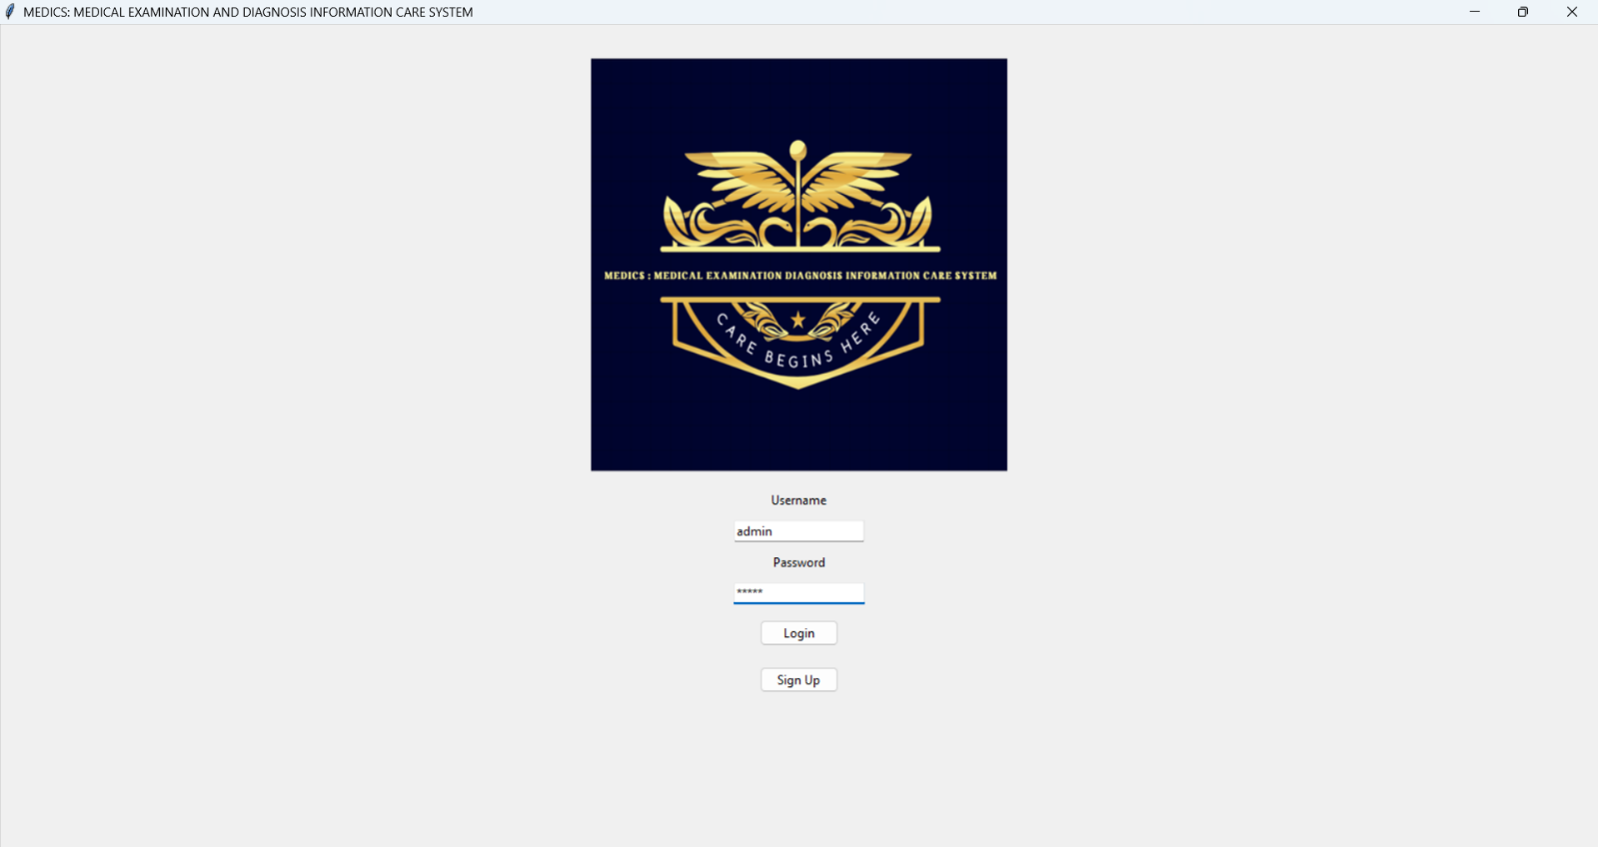
- Login Screen:

- Signup Screen:
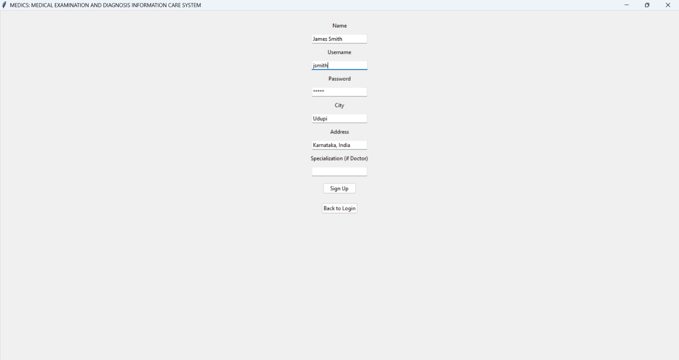
- Patient Dashboard:
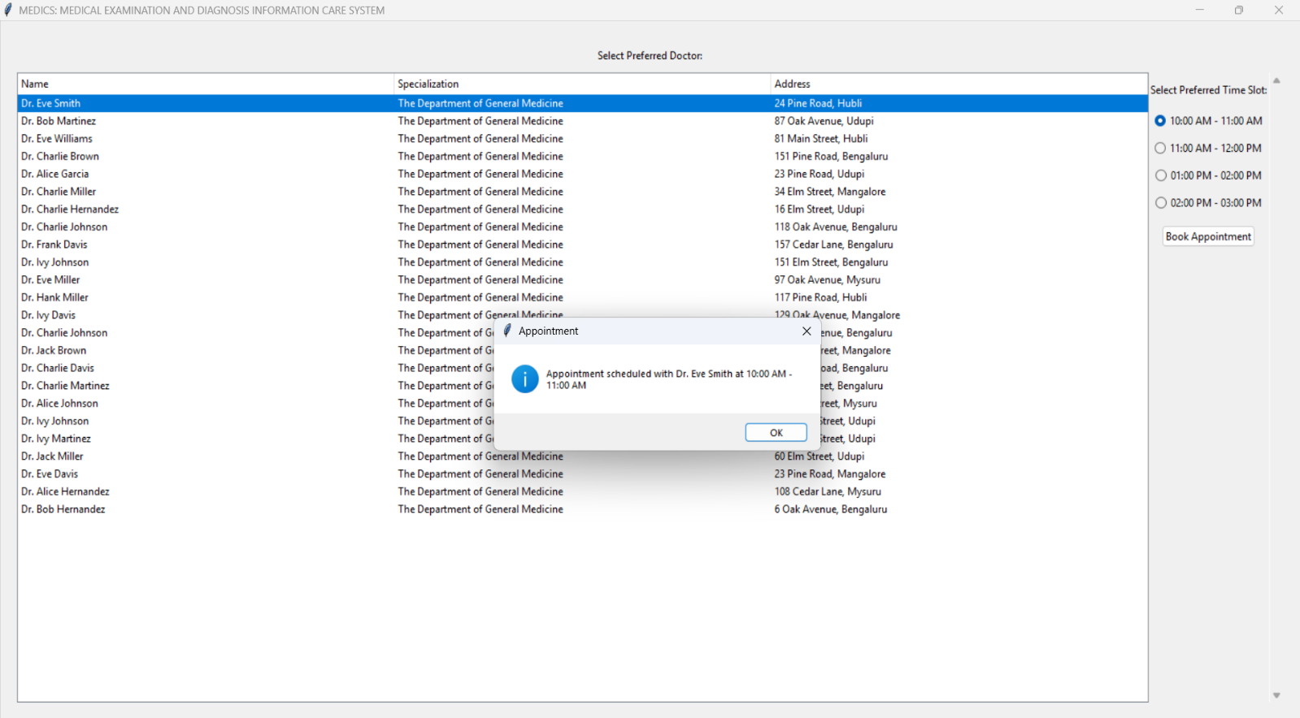
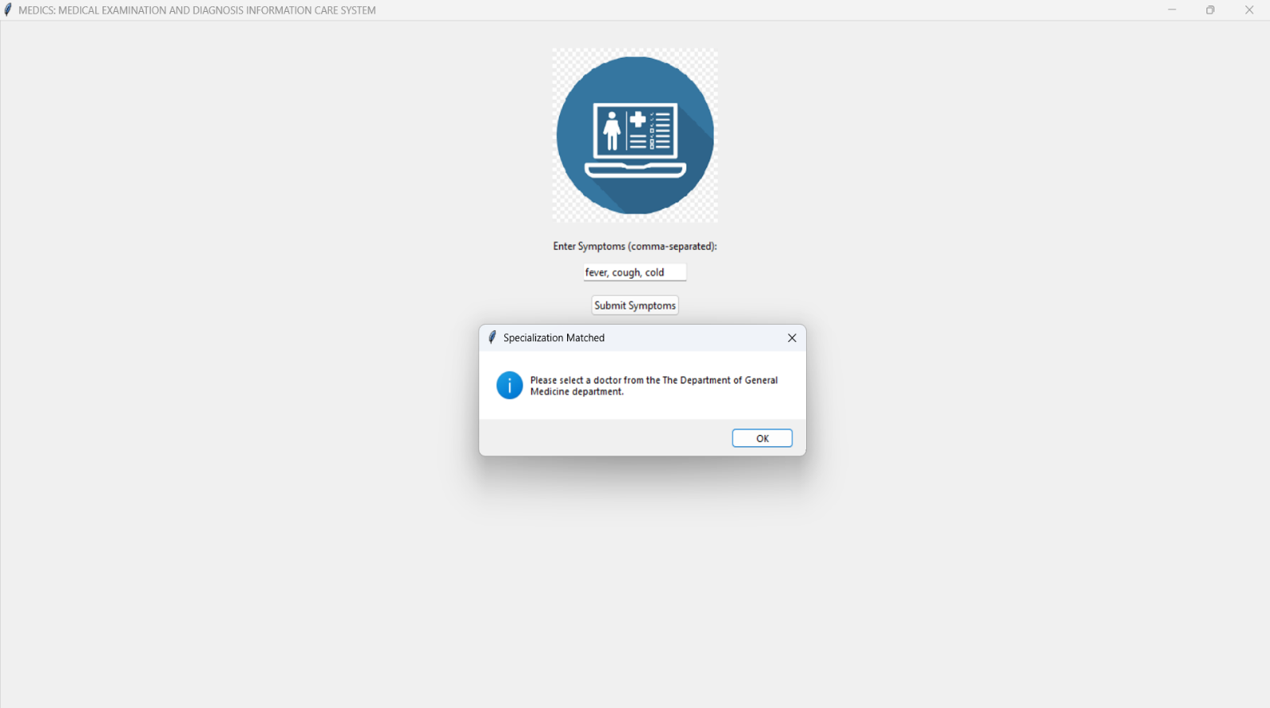

- Doctor’s Dashboard:
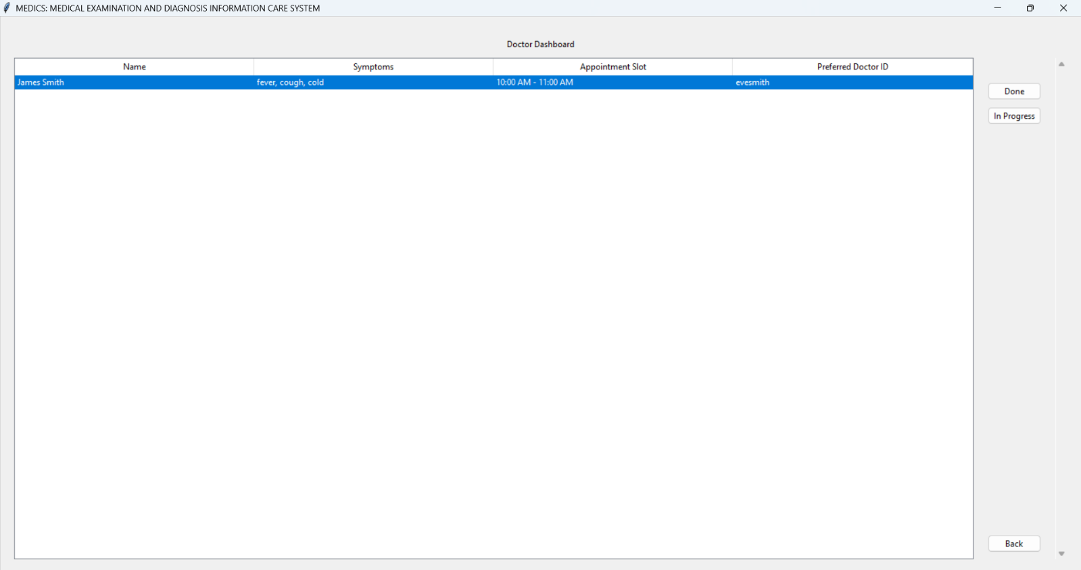

FUTURE ENHANCEMENTS

- Adding of an SOS button, when the patients clicks it an nearest am balance will be contacted and the location can be shared for fastest response.
- Defining more symptoms and integrating AI for determining to which department the patient should be routed.
- Migrate from Excel to a more robust database system (e.g., SQLite, PostgreSQL, MySQL).
- Allow users to reschedule or cancel appointments.
- Implement data encryption for sensitive information.
- Enhance the UI with modern frameworks (e.g., Tkinter themes, custom widgets).
- Implement a patient history feature to allow doctors to view past diagnoses and treatments.
- Add multi-language support to cater to a wider audience.
- Implement a feature for doctors to prescribe medications and for patients to view their prescriptions.
- Add a feature for doctors to update their availability and appointment slots.

HARWARE AND SOFTWARE REQUIREMENTS

Minimum Hardware Requirements:
- Processor: 1 GHz or faster
- RAM: 2 GB or more
- Storage: 500 MB of free disk space
- Display: 1024 x 768 resolution or higher

Minimum Software Requirements:
- Operating System: Windows 7 or later
- Python: Version 3.7 or later
- Libraries:
- tkinter (usually included with Python)
- pandas
- openpyxl
- Pillow

REFERENCE:

- Python: https://docs.python.org/3/
- Pandas: https://pandas.pydata.org/docs/
- Tkinter: https://docs.python.org/3/library/tkinter.html
- OpenPyXL: https://openpyxl.readthedocs.io/en/stable/
- Pillow: https://pillow.readthedocs.io/en/stable/
- GitHub Copilot: https://github.com/features/copilot
- JetBrains AI: https://www.jetbrains.com/ai
- Fotor: https://www.fotor.com/design/icon-maker/

Thank You

